103年放射腫瘤科專科醫師甄審
考前題庫出題格式說明

※請依照下列步驟將考題繕打於下一頁:
- 請依下一頁範例格式繕打考題。
- 本格式已設定好樣式，故請依下一頁範例格式繕打，切勿更改其樣式。
- 開始撰打考題→先於工作列上點選”格式”，下拉式選單中點選”樣式與格式”，該樣式的格式設定將會出現在螢幕的右方，請使用該格式來控制考題的格式。
      - 點選Question:可用來控制題號(題目)
      - 點選Choice:可用來控制答案選項，自動產生A) B) C) D)，若續按Enter會繼續產生E) F)…選項，需到樣式選項點選Answer
      - 點選Answer:可用來控制答案格式(本項請再註明，出題的科別細項)
      - 點選QuizLevel:難易度
      - Ref:參考文獻
      - Comment:註解
- 以上步驟若無法執行，請您用複製的方式，將下頁的範例題目複製後，貼上15次，然後將原內容文字刪除，保留格式，再將新的考題內容文字加入。
「請各委員繕打考題時，一定要使用此格式，請勿自行變更該格式」
謝謝！

「以下為範例出題格式，請各委員出題時，請以下列格式繕打，切勿變更其格式，謝謝！」
- 根據現有的臨床證據，下列有關加速局部乳房放射治療(Accelerated partial breast irradiation; APBI)之描述，何者為誤？
  - 根據2009年美國放射腫瘤學會(ASTRO)之共識，BRCA1/2 mutation(+)，pN0(i+)以及EIC(extensive intraductal component)的病人皆不適合接受APBI
  - 根據2009年美國放射腫瘤學會(ASTRO)之共識，年齡≧60歲，無淋巴血管侵犯，或荷爾蒙受體陽性的病人適合接受APBI
  - 根據2008年美國乳房外科醫師協會(ASBS)之共識，組織病理為IDC或DCIS，以及腫瘤大小≦3cm的病人適合接受APBI
  - 根據2008年美國乳房外科醫師協會(ASBS)之共識，前哨淋巴結陰性與手術切除邊緣乾淨的病人適合接受APBI
    - A (本項請再註明，出題的科別細項)
      - 難
        - Perez and Brady’s Principles and Practice of Radiation Oncology, Edward C. Halperin, David E. Wazer, Carlos A. Perez, Luther W. Brady, sixth edition; Chapter 56, p1126.
          - (A)P.1126,Table 56.39,pN0為”suitable” patient for APBI
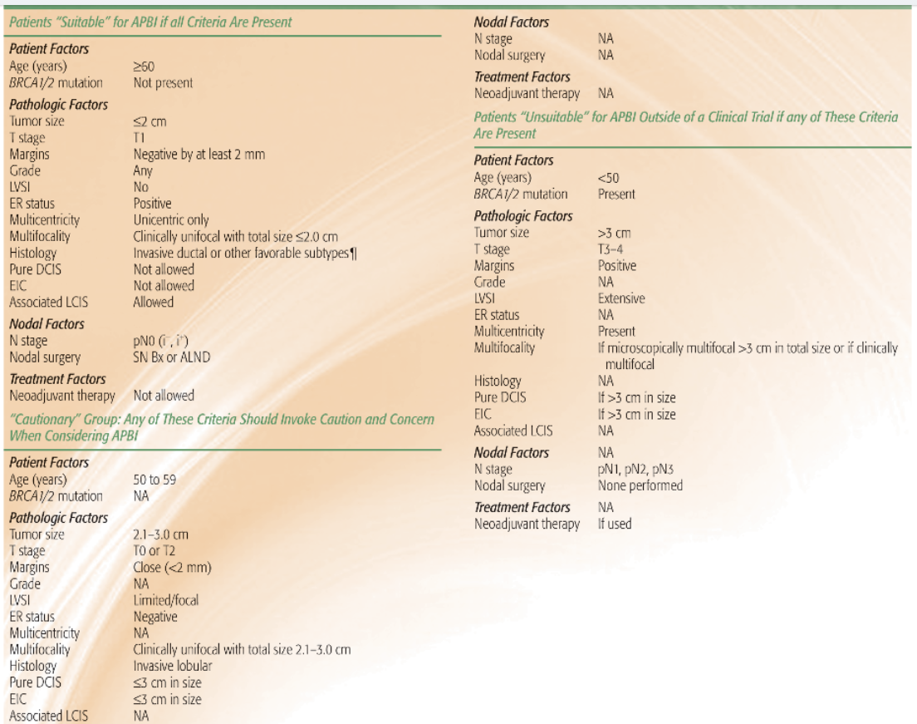
- 下列有關UK Standardisation of Breast Radiotherapy (START) Trial之描述，下列何者有誤？
  - START A分為三組，分別接受50Gy分25次，41.6Gy分13次，以及39Gy分13次的全乳房放射治療
  - 近6成的病人在全乳房放射治療後於原發腫瘤部位再給予10Gy分5次的追加劑量
  - 在統計分析後，無論是START A或B，寡分次放射治療和標準分次放射治療相比，在局部復發率均無顯著差異
  - 根據START A所計算出的乳房腫瘤的α/β值為6.4 Gy
    - D (本項請再註明，出題的科別細項)
      - 中等
        - Perez and Brady’s Principles and Practice of Radiation Oncology, Edward C. Halperin, David E. Wazer, Carlos A. Perez, Luther W. Brady, sixth edition; Chapter 56, p1090.
          - When all patients in the RMH/GOC trial (1410 patients) and START Trial A (2236) were included in a meta-analysis, the unadjusted estimate of the α/β value for local-regional relapse was 4·1 Gy (95% CI 0·9–7·4). Adjusting for known prognostic factors (age, chemotherapy, tamoxifen, lymphatic radiotherapy, type of primary surgery, boost, and pathological tumour size) gave an adjusted α/β value for local-regional relapse of 4·6 Gy (95% CI 1·1–8·1). Including all the 1202 RMH/GOC trial and 1055 START Trial A patients with available photographic, α/β values tumor control 4.6 Gy, late breast changes 3.4 Gy
- 根據1999年美國病理學會(College of American Pathologists; CAP)有關乳癌預後因子之共識，下列何者有誤？
  - 腫瘤大小對遠處轉移以及整體存活率的影響比局部復發顯著
  - Micrometastasis以及lymph node status是屬於category I的預後因子
  - Mitotic count以及DNA ploidy是屬於category II的預後因子
  - Tumor angiogenesis以及EGFR是屬於category III的預後因子
    - C (本項請再註明，出題的科別細項)
      - 難
        - Perez and Brady’s Principles and Practice of Radiation Oncology, Edward C. Halperin, David E. Wazer, Carlos A. Perez, Luther W. Brady, sixth edition; Chapter 56, p1065.
          - (C) Mitotic count為category I.
The College of American Pathologists presented a consensus statement in 1999 summarizing prognostic factors in breast cancer.Category I included tumor size, lymph node status, micrometastasis, histologic grade, mitotic count, and hormonal-receptor status. Category II included HER2/neuexpression, p53 mutations, lymphovascular invasion, and DNA ploidy. Category III included tumor angiogenesis, EGFR, transforming growth factor, Bcl-2, and cathepsin D overexpression.
- 關於RTOG-95-08 Trial之描述，下列何者為誤？
  - 本試驗之目的是在研究腦轉移病人接受全腦照射後追加立體定位放射手術是否有臨床獲益，病患選擇為1到3顆腦轉移的病人
  - 接受全腦照射加上立體定位放射手術相較於單獨接受全腦照射對於單一顆腦轉移的病人有存活上的顯著獲益
  - 接受全腦照射加上立體定位放射手術相較於單獨接受全腦照射，病患在局部控制率有較佳的結果
  - 接受全腦照射後加上立體定位放射手術相較於單獨接受全腦照射的腦轉移病人有較佳的身體狀態(performance status)，但也伴隨著較高的腦水腫機率
    - D (本項請再註明，出題的科別細項)
      - 易
        - Perez and Brady’s Principles and Practice of Radiation Oncology, Edward C. Halperin, David E. Wazer, Carlos A. Perez, Luther W. Brady, sixth edition; Chapter 93, p1768.
          - In the third study, RTOG-95-08, the primary end point was overall survival, which was not statistically different between the WBRT plus SRS and WBRT alone arms (6.5 months and 5.7 months, respectively; P = .1356), although the SRS boost improved the survival in the subgroup (planned analysis) of patients with single metastasis.¹⁹ For secondary end points, the local control and performance measures, were higher in the SRS boost arm, but this did not translate into a lower death rate from neurologic progression. Multiple, unplanned subgroup analyses were made, and an overall survival benefit with the SRS boost was found in several subgroups that included patients with RPA class 1, tumor size ≥2 cm, and non–small cell lung cancer or metastatic squamous histology from any site. Unfortunately, these subset analyses were not planned or prespecified, and the probability values needed for significance should have been adjusted for inflation of the type I error. When this was done, none of these subgroup analyses showed a positive benefit for SRS.²⁰ On the other hand, this trial did demonstrate that SRS is associated with lower edema and corticosteroid use, countering a commonly held notion that SRS actually increases the edema risk. However, regarding the major end points for multiple metastases, this study should be considered a negative trial.
- 根據目前的臨床證據，有些DCIS的病人接受乳房保留手術後可考慮不用接受後續的輔助放射治療，下列何者不是評估的因子？
  - 腫瘤大小
  - 手術邊緣狀態
  - 組織病理的分化程度
  - 荷爾蒙受體狀態
    - D (本項請再註明，出題的科別細項)
      - 難
        - Perez and Brady’s Principles and Practice of Radiation Oncology, Edward C. Halperin, David E. Wazer, Carlos A. Perez, Luther W. Brady, sixth edition; Chapter 56, p1041.
          - One of these studies has proposed a scoring system using histopathologic features including tumor size, grade, and margin width in an attempt to stratify patients according to local failure risk after excision plus or minus whole-breast irradiation. Each variable was assigned a score of 1 to 3, and the sum total defined the Van Nuys Prognostic Index.
- 根據目前的臨床證據，在接受乳房保留手術後之乳癌病人，全乳房放射治療後是否於原發腫瘤處追加劑量的敘述，下列何者為誤？
  - Lyon Boost trial挑選第一期及第二期(≦3cm)的病人，追加劑量組之局部復發率從4.5%下降到3.6%，但在self-assessed cosmetic response上並無顯著差異
  - 在EORTC boost trial中，腫瘤切除邊緣不完全的病人，在原發腫瘤處追加劑量到26Gy和10Gy相比，在局部復發率或是整體存活率均無顯著差異
  - 根據EORTC boost trial，在追蹤五年的統計分析中，年齡大於50歲的族群接受追加劑量有最大的受益，局部復發率從19.5%下降到10.2%
  - 在EORTC boost trial中，追蹤到十年後，所有接受追加劑量的病人族群皆有顯著獲益，Hazard ratio為0.59
    - C (本項請再註明，出題的科別細項)
      - 中等
        - Perez and Brady’s Principles and Practice of Radiation Oncology, Edward C. Halperin, David E. Wazer, Carlos A. Perez, Luther W. Brady, sixth edition; Chapter 56, p1111-1112.
          - Bartelink et al.⁴⁰⁴ reported the results of the EORTC trial in which, after complete lumpectomy and axillary dissection, patients with stage I or II breast cancer received 50 Gy of radiation to the whole breast in 2-Gy fractions over a 5-week period and were randomly assigned to receive either no further local treatment (2,657 patients) or a boost of 16 Gy, usually given in 8 fractions by electron beam (2,661 patients). In the initial report, with a median follow-up of 5.1 years, local recurrences were observed in 182 of the 2,657 patients in the standard-treatment group and 109 of the 2,661 patients in the additional-radiation group. The 5-year actuarial rates of local recurrence were 7.3% and 4.3%, respectively (P <.001). Patients 40 years of age or younger benefited most; at 5 years, their rate of local recurrence was 19.5% with standard treatment and 10.2% with additional radiation (RR 0.46; 99% CI, 0.23 to 0.89; P = .002). In an update of this study published in 2007, with a median follow-up of 10.8 years, a significant benefit to the boost was noted in all age groups, with an overall hazard ratio of 0.59 in favor of the boost⁴⁰⁵
- 下列有關於局部晚期乳癌的敘述，何者為誤？
  - 根據Danish Breast Cancer Cooperative Group 82b trial，手術後加上輔助放射治療與化學治療與僅接受輔助化學治療的病人相比較，加上放射治療在整體存活率與無病存活率在統計學上有顯著差異
  - 在Danish trial的試驗設計中，放射治療範圍有涵蓋內乳淋巴結
  - 在Danish trial與Vancouver trial中，腋下淋巴廓清術平均清除的淋巴結數目均少於十顆
  - 在Danish 82b中所挑選的病人均為停經前的病人，而在Danish 82c中所挑選的病人均為停經後的病人
    - C (本項請再註明，出題的科別細項)
      - 易
        - Perez and Brady’s Principles and Practice of Radiation Oncology, Edward C. Halperin, David E. Wazer, Carlos A. Perez, Luther W. Brady, sixth edition; Chapter 56, p1090.
          - (C) In the Vancouver trial, the median number of resected lymph nodes was 11.
In the Danish studies, the median number of axillary lymph nodes resected was only seven,⁶⁹ which is approximately 50% of the number reported from studies conducted in the United States. In addition, 76% of the patients had <10 lymph nodes removed, and 15% had three or fewer lymph nodes removed.⁶⁹ In the Vancouver trial, the median number of resected lymph nodes was 11.⁷³
- 根據NCCN 2014版本於乳房篩檢的建議，針對高風險族群，除乳房攝影外，亦建議乳房核磁共振造影檢查，但不包括下列何者?
  - BRCA1/2 mutation的病人
  - 一等親內有Li-Fraumeni syndrome的病人
  - 有得過乳癌的病人
  - 一等親內有Cowden and Bannayan-Riley-Ruvalcaba syndrome的病人
    - C (本項請再註明，出題的科別細項)
      - 中等
        - NCCN guidelines version 1.2014; Breast cancer Screening and Diagnosis.
          - (C) 屬於Insufficient evidence to recommend for or against MRI screening 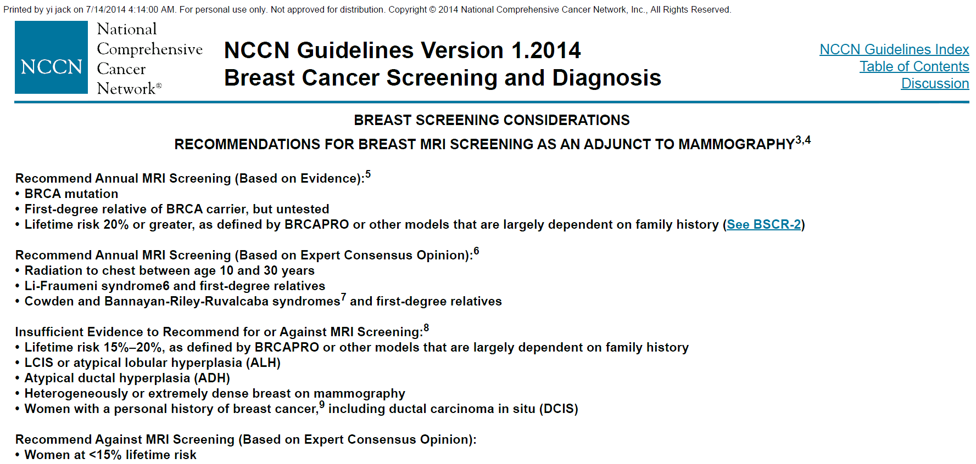
- 關於原位葉狀乳癌(Lobular carcinoma in situ; LCIS)之描述，下列何者為誤？
  - LCIS通常為荷爾蒙受體陽性，並常在病理組織中觀察到E-cadherin的表現
  - LCIS的病人中約有35—59%會有雙側乳房侵犯
  - LCIS佔所有非侵襲性乳癌的比例小於15%，且通常發生在停經前婦女
  - LCIS不會發生在男性病人身上
    - A (本項請再註明，出題的科別細項)
      - 難
        - Perez and Brady’s Principles and Practice of Radiation Oncology, Edward C. Halperin, David E. Wazer, Carlos A. Perez, Luther W. Brady, sixth edition; Chapter 55, p1033.
          - LCIS has been reported to present with a multicentric distribution in up to 90% of mastectomy specimens, with bilateral involvement in 35% to 59%.^{5,6,7} LCIS cells are commonly estrogen-receptor positive, although overexpression of c-erbB-2 and p53 are uncommon.^{4,8,9,10} The loss of E-cadherin is often observed,^{8,11,12} and the absence of this adhesion molecule may explain the growth pattern seen with LCIS.
- 根據腦轉移GPA(Graded Prognostic Assessment) score之評分標準，若一位46歲女性病患，KPS 70分，診斷為非小細胞肺癌第四期合併有兩顆腦轉移及胸椎第11節骨轉移，則病人之GPA Score應為幾分？
  - 0-1
  - 1.5-2.5
  - 3.0
  - 3.5-4.0
    - B (本項請再註明，出題的科別細項)
      - 易
        - Sperduto PW, Kased N, Roberge D, et al. Summary report on the Graded Prognostic Assessment: an accurate and facile diagnosis specific tool to estimate survival for patients with brain metastases. J Clin Oncol 2012:30:419-425
          - Age<50→1.0, KPS:70→0.5, ECM(+)→0,No. of brain metastasis:2→0.5, total:2.0 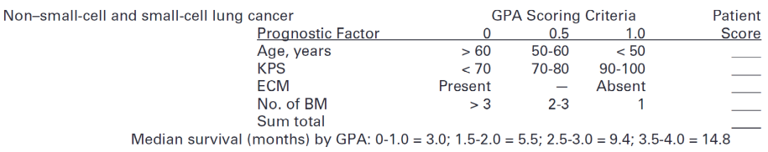
- 關於黑色素瘤(melanoma)的敘述，下列何者為誤？
  - 約有15%的黑色素瘤是由melanocytic nevi轉變而成
  - Lentigo maligna melanoma約佔頭頸部黑色素瘤的一成，主要發生在老年病人的臉與耳部
  - 在初診斷時約有15%的病人會有淋巴結侵犯
  - 手術切除為黑色素瘤主要的治療方式，若腫瘤的厚度>2.0mm，則手術切除的邊緣至少需距離腫瘤1.0cm
    - D (本項請再註明，出題的科別細項)
      - 難
        - Perez and Brady’s Principles and Practice of Radiation Oncology, Edward C. Halperin, David E. Wazer, Carlos A. Perez, Luther W. Brady, sixth edition; Chapter 56, p1090.
          - (D)2.0cm才足夠 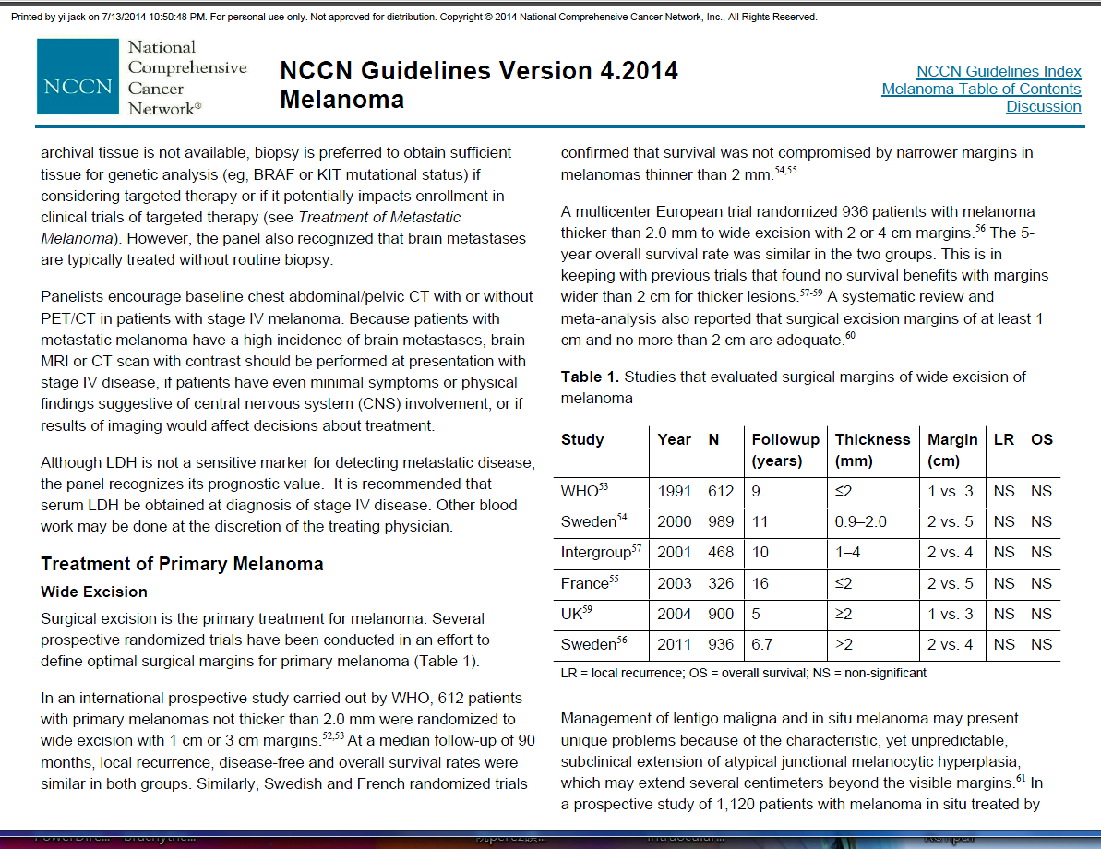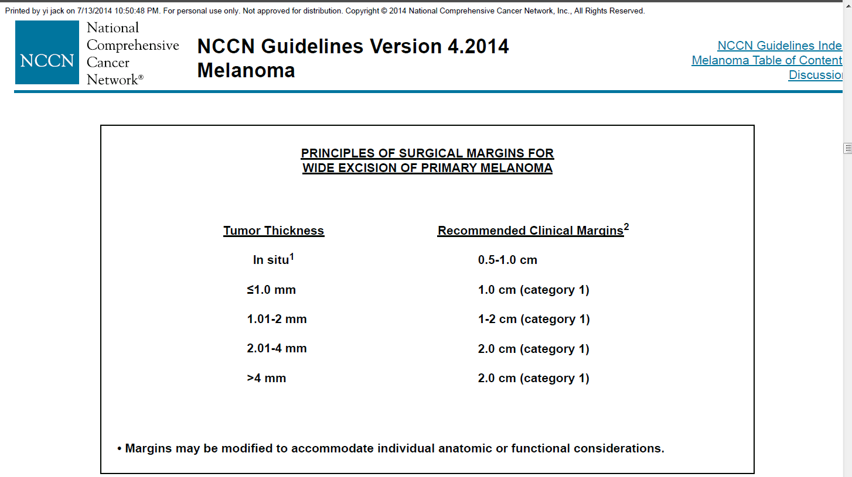
- 關於卡波西氏肉瘤(Kaposi’s sarcoma)之敘述，下列何者為誤？
  - Human herpesvirus-8 (HHV-8)在卡波西氏肉瘤的所有型態中皆有機會檢測到
  - 近年來因抗病毒藥物的進步，愛滋病患的整體存活率得以提升，而卡波西氏肉瘤的發生率也隨之增加
  - 在與HHV-8感染相關的腫瘤組織中，常可以測到高濃度的Interleukin-6
  - 在Stelzer and Griffin的前瞻性臨床研究中，40Gy分20次和8Gy 1次相比，有較高的反應率、較低的色素殘留率和較長時間的腫瘤控制率
    - B (本項請再註明，出題的科別細項)
      - 中等
        - Perez and Brady’s Principles and Practice of Radiation Oncology, Edward C. Halperin, David E. Wazer, Carlos A. Perez, Luther W. Brady, sixth edition; Chapter 34, p642.
          - (B)發生率下降
With the introduction of progressively more effective antiretroviral therapies, the incidence of KS in the United States, as a component of AIDS, has diminished over time. A report from the International Collaboration on HIV and Cancer evaluating the cancer incidence from 23 prospective studies that included 47,936 HIV-seropositive individuals from North America, Europe, and Australia showed that the adjusted incidence rate for KS declined from 15.2 in the period of time from 1992 through 1996 to 4.9 between 1997 and 1999.¹¹⁰
- 關於乳癌的病理型態，下列敘述何者錯誤？
  - Spindle cell carcinoma是惡性度低的病理型態，不容易發生轉移
  - Tubular carcinoma是惡性度低的病理型態，有較好的預後
  - Medullary carcinoma是惡性度低的病理型態，有較好的預後
  - Breast lymphoma多源自T cell
    - D (本項請再註明，出題的科別細項)
      - 易
        - Perez and Brady’s Principles and Practice of Radiation Oncology, Edward C. Halperin, David E. Wazer, Carlos A. Perez, Luther W. Brady, sixth edition; Chapter 56, p1064.
          - (D)較多為Bcell. Primary mammary lymphomas are rare. In a study of 35 cases, including 16 primary lymphomas, diffuse large cell lymphoma was present in 10 of 16 primary and 14 of 18 secondary cases.²²⁰ Lymphoepithelial lesions in ducts and lobules and frequent vascular involvement were found in both primary and secondary cases. Immunohistochemistry studies of 13 tumors showed that 12 were B cell in origin, and one was a primary T-cell lymphoma.
- 根據EORTC 22952-26001 phase III trial，下列敘述何者錯誤？
  - 本試驗將有1到3顆腦轉移的病人經手術或放射手術治療後，隨機分配到全腦照射組(30Gy分10次)或觀察組
  - 觀察組與全腦照射組在整體存活率的統計上無顯著差異，但全腦照射可以減少手術後或是放射手術後的顱內復發風險與neurologic deaths的機率
  - 全腦照射組與觀察組相比，全腦照射不僅可減低原發部位的腦轉移復發風險，也可降低新發生腦轉移之風險
  - 全腦照射組與觀察組相比，全腦照射對於改善functional independence在統計學上有顯著差異
    - D (本項請再註明，出題的科別細項)
      - 中等
        - Perez and Brady’s Principles and Practice of Radiation Oncology, Edward C. Halperin, David E. Wazer, Carlos A. Perez, Luther W. Brady, sixth edition; Chapter 56, p1090.
          - (D)After radiosurgery or surgery of a limited number of brain metastases, adjuvant WBRT reduces intracranial relapses and neurologic deaths but fails to improve the duration of functional independence and overall survival
- 根據現有的臨床證據，下列有關手術中放射治療(Intraoperative radiation therapy; IORT)應用於乳癌之描述，何者有誤？
  - ELIOT trial之實驗組是利用4-10 MeV之電子射束進行手術中放射治療，劑量為21Gy
  - TARGIT-A trial之試驗設計是利用6 MV X-ray進行手術中放射治療，與常規全乳房放射治療相比較
  - 根據TARGIT-A研究結果顯示，手術中放射治療組和常規放射治療組相比，4年之局部復發率分別為1.2%和0.95%，在統計學上並無顯著差異
  - 根據TARGIT-A研究結果顯示，手術中放射治療組和常規放射治療組相比，中度以上副作用發生率分別為3.3%和3.9%，在統計學上並無顯著差異

    - B (本項請再註明，出題的科別細項)
      - 易
        - Targeted intraoperative radiotherapy versus whole breast radiotherapy for breast cancer (TARGIT-A trial): an international, prospective, randomised, non-inferiority phase 3 trial Vaidya JS, Lancet. 2010 Jul 10;376(9735):91-102.
          - (B) Arm 1)Intra-op RT with Intrabeam 50 kV device 20 Gy at surface vs Arm 2) WBRT (as per each individual center, typically 40-56 Gy with/without boost 10-16 Gy).

